**Circle Vs Square Game Manual**

**External Comments**

The objective of this game known as *Circle vs Square* is to get through as many blocks as possible and beat the high score without dying. To achieve this objective, use this manual to learn how the game works and how to play effectively.

**Graphics**

Current Score High Score

Coin

Block

Block Health

Player

Player Health

**Controls**

The only controllable object in the game is the player whose position across the screen is controlled by the location of the mouse.

The game can also be paused and un-paused by pressing the “Escape” key.

**Gameplay**

The player starts off close to the bottom of the screen as blocks start moving down towards the player. If the player hits a block, the block’s health will continuously go down, increasing the player’s score, until it is zero at which point the block will break and award the player with an extra 5 points. However, at the same time, the player’s health will also be decreasing so it is advantage to avoid the falling blocks.

**Block Rows-**

Every 190 game ticks there will be a row of blocks spawned where the player must choose to go through a block. It is recommended to target the block with the lowest health as it will result in the lowest amount of health lost for the player.

**Coins-**

In order for the player to not die, they must collect coins which randomly spawn and move down with the blocks. Each collected coin will increase the player’s health randomly by 2 to 8 points.

The game continues to generate random blocks and coins until the player eventually loses at which point a message box will appear stating the player’s score and if they beat their previous high score as shown in the picture below. The game closes once the player presses the 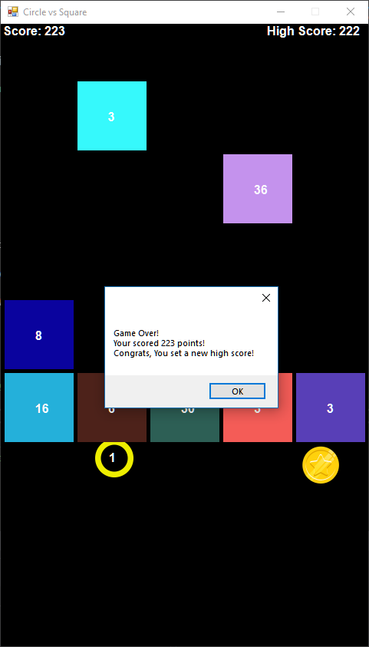“OK” button.

**Errors**

There is only one error in this game which causes the player to move past the side of a block if the mouse is moved past the block. Otherwise, all functions work as intended.